STUDY MISSION OF THE 8TH BATCH OF HIGHER DIPLOMA OF SECURITY STUDIES (BESS 8) TO CAMEROON’S STRATEGIC COMPANIES

The 8th Batch of the Higher Degree of Security Studies (BESS 8) last Wednesday 29 June 2022 carried out a study mission to two of Cameroon’s State companies, namely Cameroon Telecommunications (CAMTEL) and the Hydrocarbons Prize Stabilisation Fund (CSPH). The mission was headed by the Colonel, Director of Studies, who represented the Brigadier General, Director General of EIFORCES, with the assistance of the Lieutenant-colonel, Head of Division for Higher Education and the Divisional Commissioner, Head of the Division’s Evaluations Office.
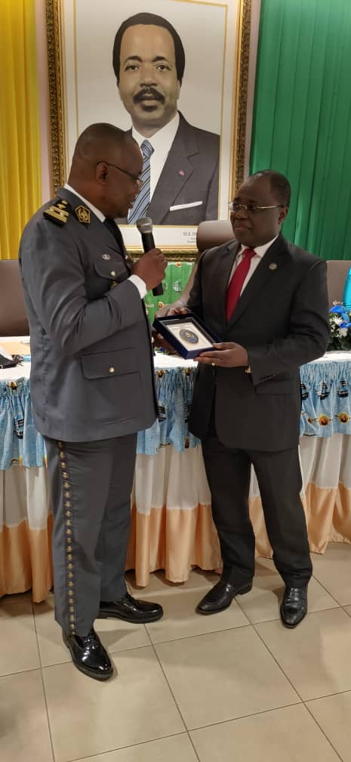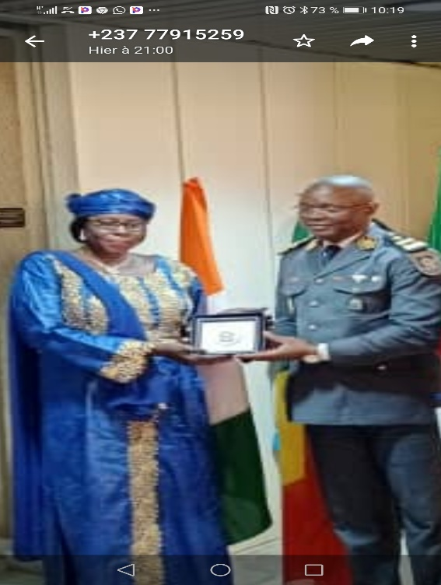
Offer of souvenir awards to the DG of CSPH and the Representative of the DG of CAMTEL

This in situ mission enabled the 28 BESS 8 trainees, senior Gendarmerie officers and senior Police officials from Cameroon (10), Congo-Brazzaville (09), Côte d'Ivoire (02), Mali (06) and Togo (01), to gain firsthand knowledge of the actual functioning and management of Cameroon's two security and strategic giants.
While for CAMTEL with capital entirely vested in the State of Cameroon the main mission is to regulate the digital economy sector of Cameroon's telecommunications digital economy, CSPH skillfully ensures the regulation of hydrocarbon prices, by equally ensuring their supply throughout the national territory.
The two companies thus enable Cameroon, firstly, to ensure proper and effective control in preserving and protecting the security of electronic telecommunications and, secondly, to protect its population from the hazards of recurrent fluctuations in the prices of petroleum products. Both institutions enjoy efficient management, with mankind and the general interest at the centre of their respective activities.
Following the presentations and fruitful discussions with the managers of these companies, BESS 8 returned to their Awaé base with a wealth knowledge on the two areas of intervention and a clearer insight into the good practices for securing telecommunications in Cameroon, as well as the strategic measures taken for the safe and equitable management of the sale and supply of petroleum products to the entire Cameroonian population./-
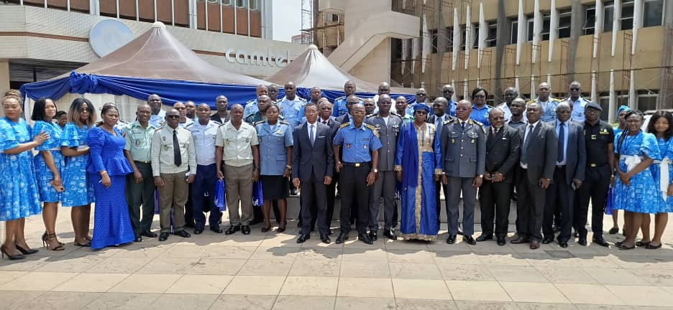
Family photograph : CAMTEL Staff and EIFORCES Delegation

